Test Case: tc003_SPX_Dev5_Crear_Requisicion_Spot_Tipo_Cobro_CC_Urgent
Step 1 - Enter username and password and click to button Enter : Credentials Entered
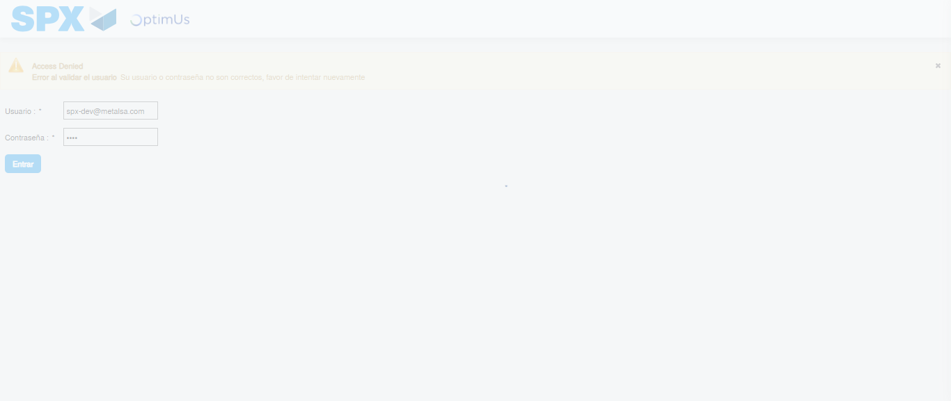Image file-name: QC_Testing-tc003_SPX_Dev5_Crear_Requisicion_Spot_Tipo_Cobro_CC_Urgent-1783358878034

Step 2 - Select to UEN and Access to Spot Buy Requisitions : UEN Correctly selected and Correct access
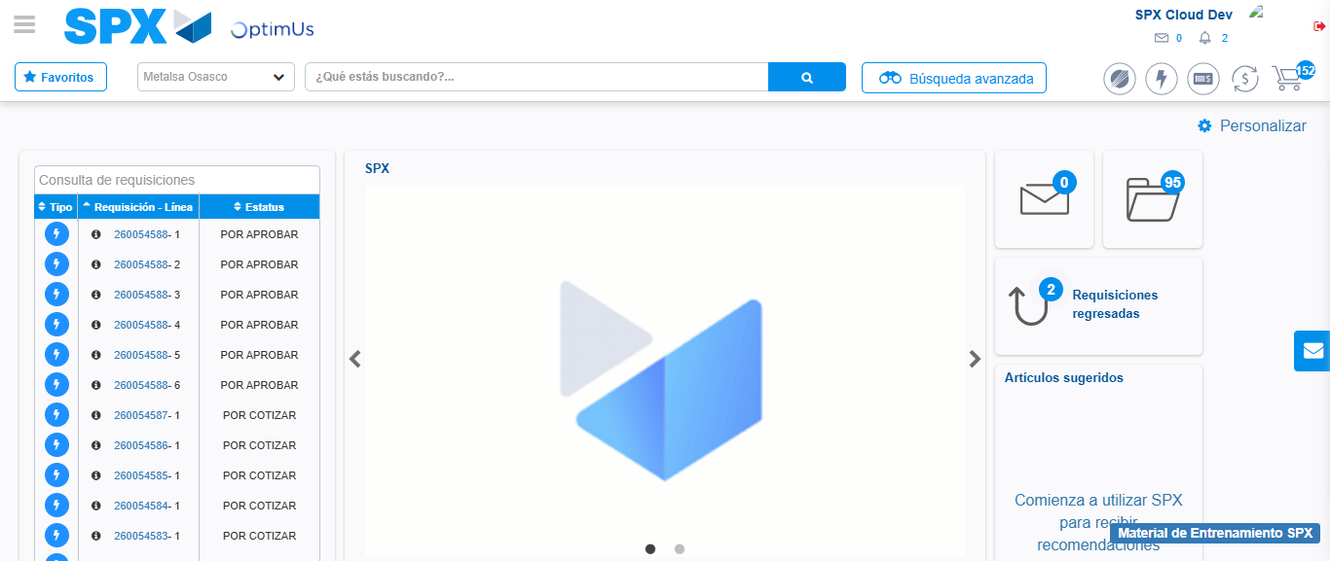Image file-name: QC_Testing-tc003_SPX_Dev5_Crear_Requisicion_Spot_Tipo_Cobro_CC_Urgent-1783358904400

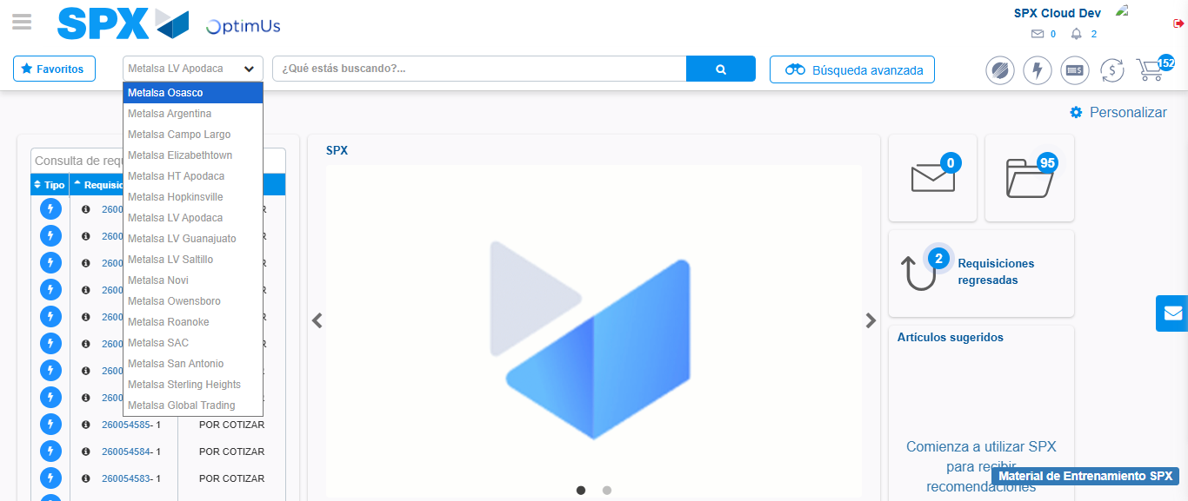Image file-name: QC_Testing-tc003_SPX_Dev5_Crear_Requisicion_Spot_Tipo_Cobro_CC_Urgent-1783358907129

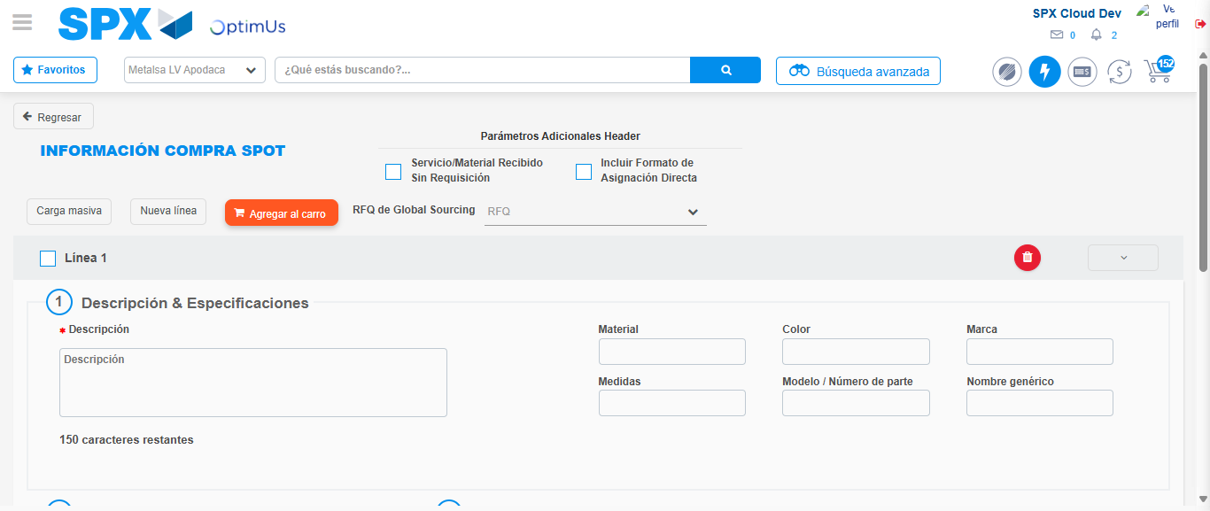Image file-name: QC_Testing-tc003_SPX_Dev5_Crear_Requisicion_Spot_Tipo_Cobro_CC_Urgent-1783358925822

Step 3 - Data Capture Spot Buy Requisition: Data captured correctly
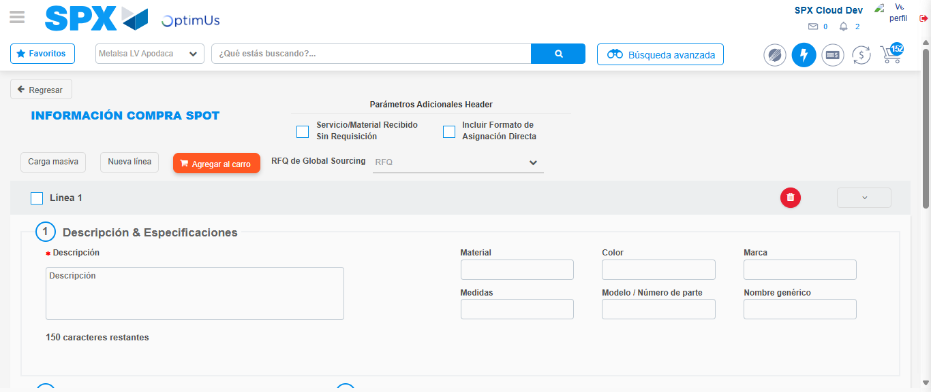Image file-name: QC_Testing-tc003_SPX_Dev5_Crear_Requisicion_Spot_Tipo_Cobro_CC_Urgent-1783358926079

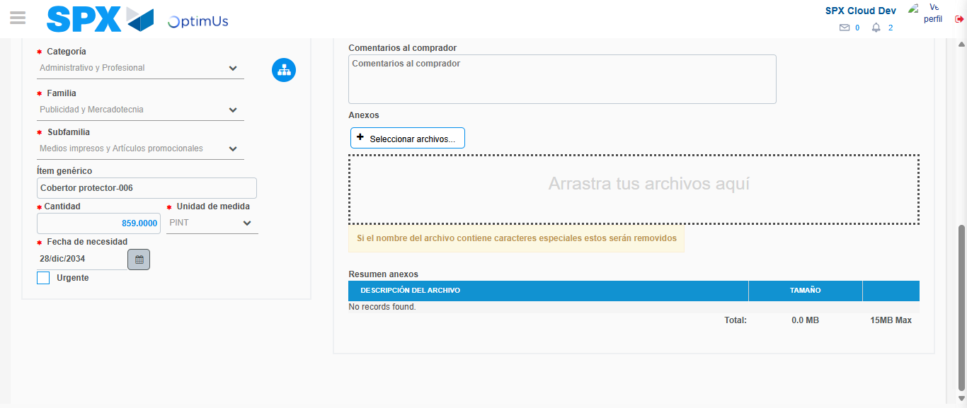Image file-name: QC_Testing-tc003_SPX_Dev5_Crear_Requisicion_Spot_Tipo_Cobro_CC_Urgent-1783358937524

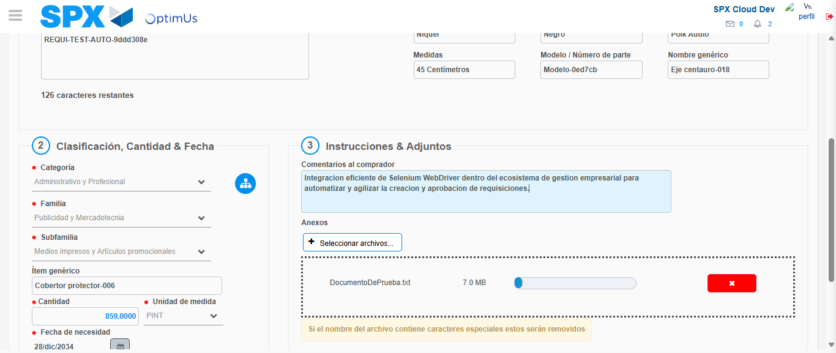Image file-name: QC_Testing-tc003_SPX_Dev5_Crear_Requisicion_Spot_Tipo_Cobro_CC_Urgent-1783358938328

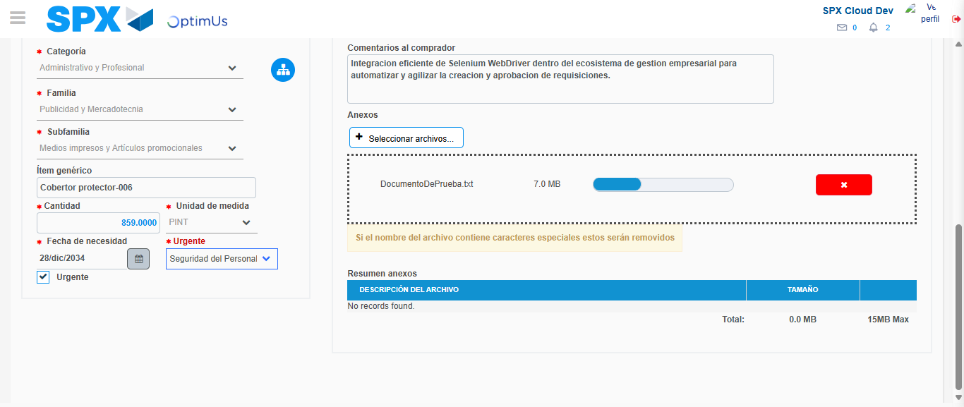Image file-name: QC_Testing-tc003_SPX_Dev5_Crear_Requisicion_Spot_Tipo_Cobro_CC_Urgent-1783358941554

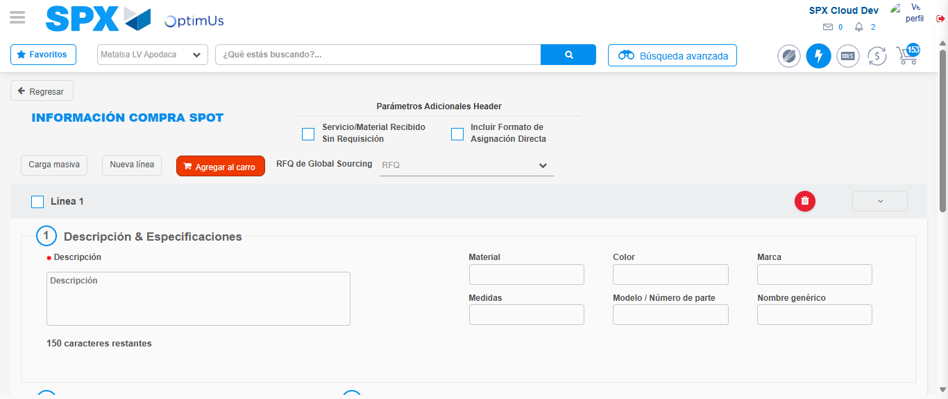Image file-name: QC_Testing-tc003_SPX_Dev5_Crear_Requisicion_Spot_Tipo_Cobro_CC_Urgent-1783358951040

Step 7 - Return to Main Page SPX : Return to Main Page SPX
Image file-name: QC_Testing-tc003_SPX_Dev5_Crear_Requisicion_Spot_Tipo_Cobro_CC_Urgent-1783358904400

Image file-name: QC_Testing-tc003_SPX_Dev5_Crear_Requisicion_Spot_Tipo_Cobro_CC_Urgent-1783358907129

Image file-name: QC_Testing-tc003_SPX_Dev5_Crear_Requisicion_Spot_Tipo_Cobro_CC_Urgent-1783358925822

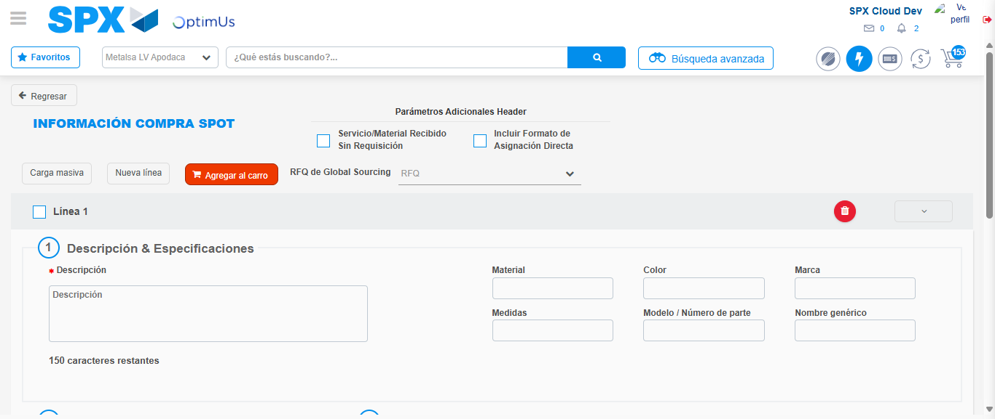Image file-name: QC_Testing-tc003_SPX_Dev5_Crear_Requisicion_Spot_Tipo_Cobro_CC_Urgent-1783358953224

Image file-name: QC_Testing-tc003_SPX_Dev5_Crear_Requisicion_Spot_Tipo_Cobro_CC_Urgent-1783358953428

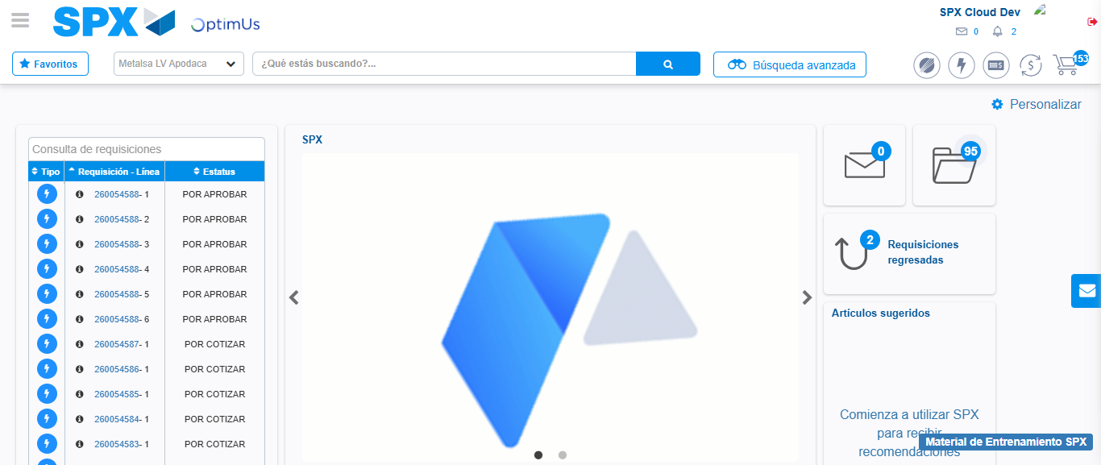Image file-name: QC_Testing-tc003_SPX_Dev5_Crear_Requisicion_Spot_Tipo_Cobro_CC_Urgent-1783358974620

Step 8 - Log Out : Log Out SPX
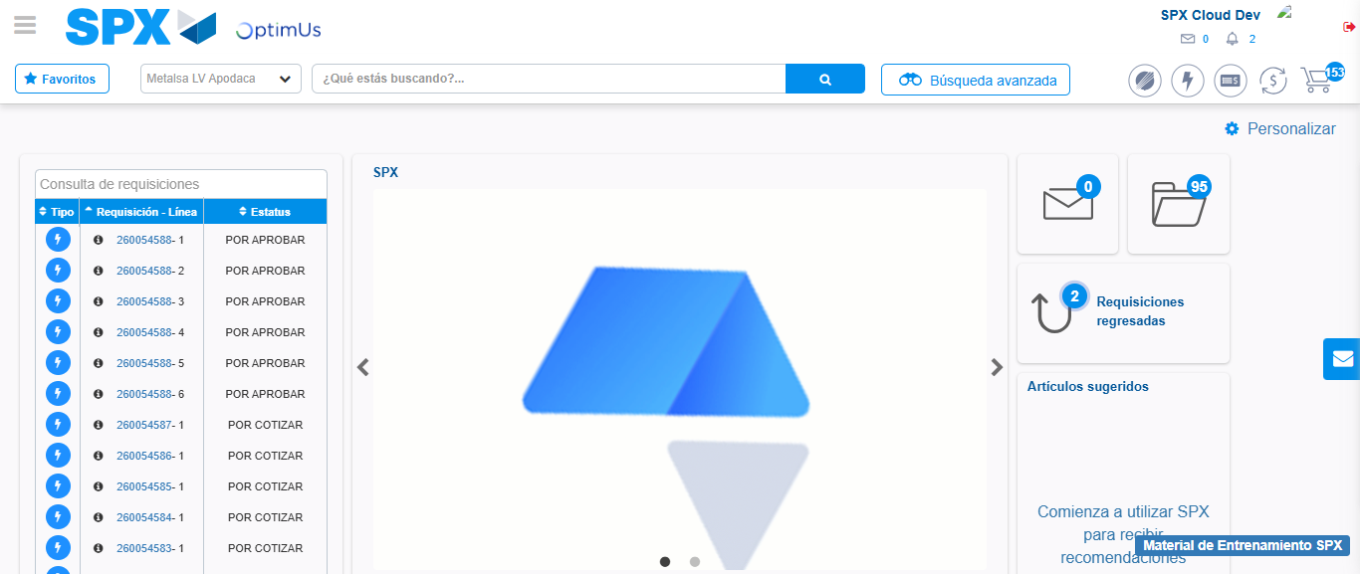Image file-name: QC_Testing-tc003_SPX_Dev5_Crear_Requisicion_Spot_Tipo_Cobro_CC_Urgent-1783358974976

